# ***SpaceX Falcon 9 first stage Landing Prediction***

This capstone extends points to anticipate the effective landing of the Bird of prey 9 to begin with organize. SpaceX unmistakably advances Hawk 9 rocket dispatches on its site, advertising them at a toll of $62 million, which is essentially lower than the costs charged by other suppliers, frequently surpassing $165 million per dispatch. The key figure contributing to these investment funds is SpaceX's capacity to reuse the primary structure of the rocket. Thus, in order to precisely decide whether the primary arrangement will arrive effectively, we will appraise the cost of a dispatch. This data would be important for an interchange company looking to compete with SpaceX for a rocket dispatch contract. In this lab, you may accumulate information from an API and guarantee that it is legitimately designed. The illustration given underneath illustrates a effective dispatch.

***Targets***

* Ask to the SpaceX API
* Clean the asked information

***Import Libraries***

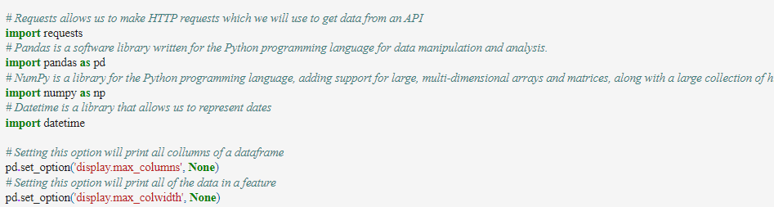

***The booster name  
  
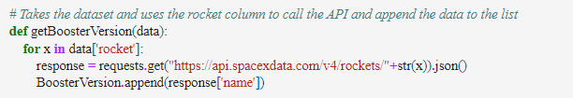  
  
The launchpad  
  
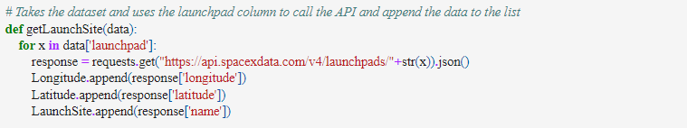  
  
The payload  
  
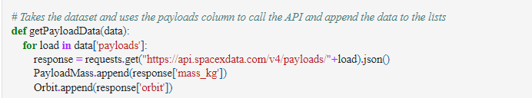***

***The study aims to record the landing results, type, number of flights, gridfin usage, reuse, legs, landing cushion, core number, reuse frequency, and center serial.  
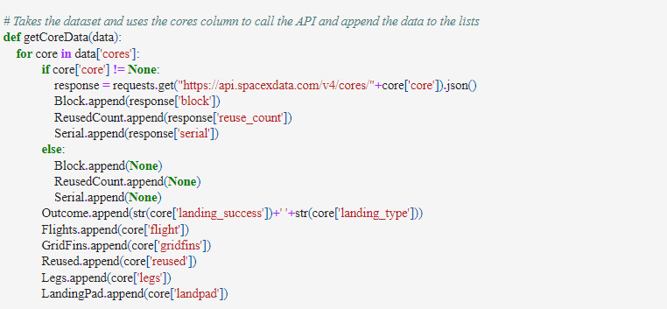  
  
SpaceX API with the following URL:  
  
Response:***

***  
Print:***



***Output:  
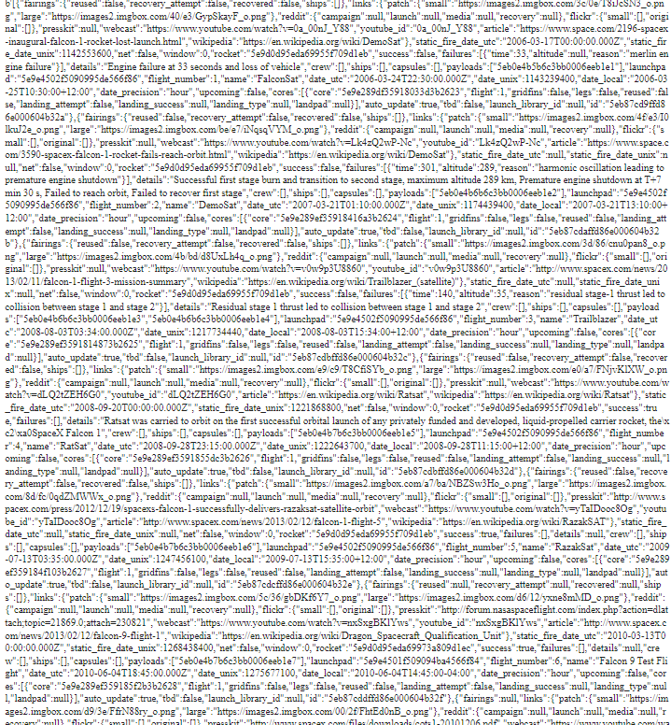  
  
Task 1: Request and parse the SpaceX launch data using the GET request***

***  
The request was successfully processed with the 200 status response code:  
***

***The response content is decoded as a JSON using.json() and converted into a Pandas dataframe using.json_normalize()  
***

***Using the dataframe  
  
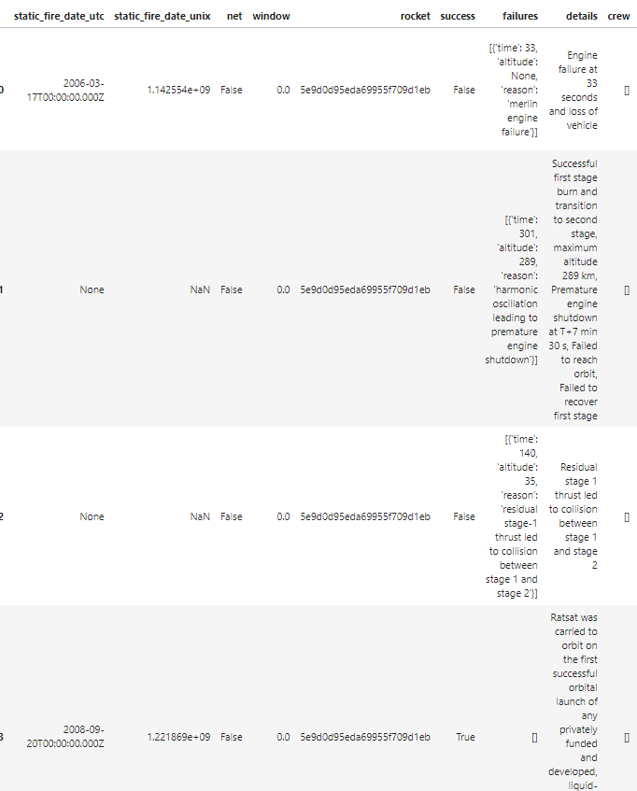  
  
The API will be utilized to retrieve information about launches using the IDs provided, specifically focusing on rocket, payloads, launchpad, and cores.  
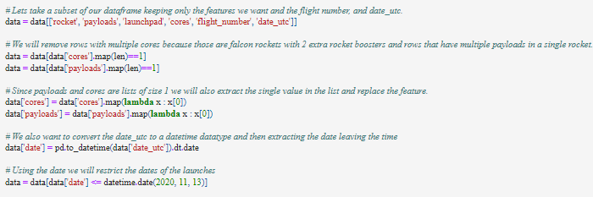  
The data collected from these requests will be stored in lists and utilized to create a new dataframe.***

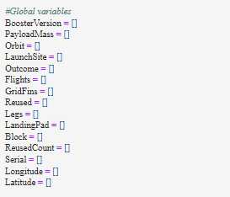

***The functions apply global outputs to variables, such as the BoosterVersion variable, which is empty before applying the getBoosterVersion function.***



***GetBoosterVersion   
  
update  
  
['Falcon 1', 'Falcon 1', 'Falcon 1', 'Falcon 1', 'Falcon 9']***





***The dataset will be constructed by combining the obtained data into a dictionary.***

***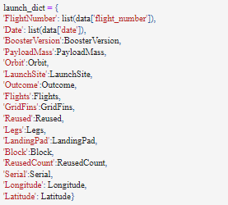  
Next, we need to create a Pandas data frame from the dictionary launch_dict.  
  
Show the summary of the dataframe***

***  
  
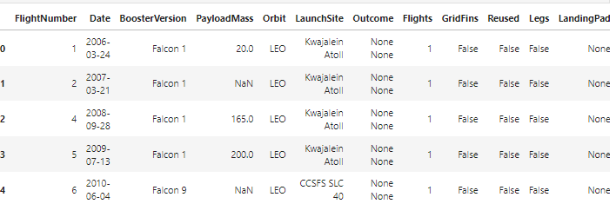  
  
Task 2: Filter the dataframe to only include Falcon 9 launches***

***  
  
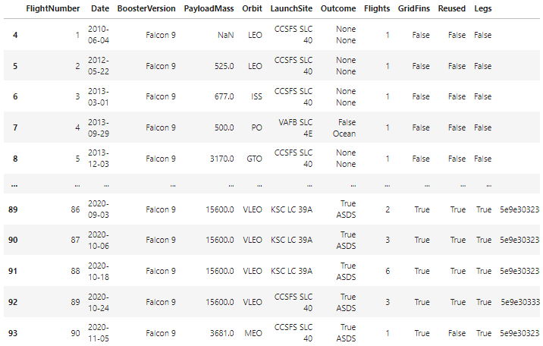  
  
Data Wrangling***



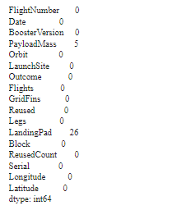

### ***Task 3: Dealing with Missing Values***

***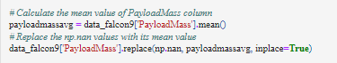  
  
data_falcon9.to_csv('dataset_part_1.csv', index=False)***



